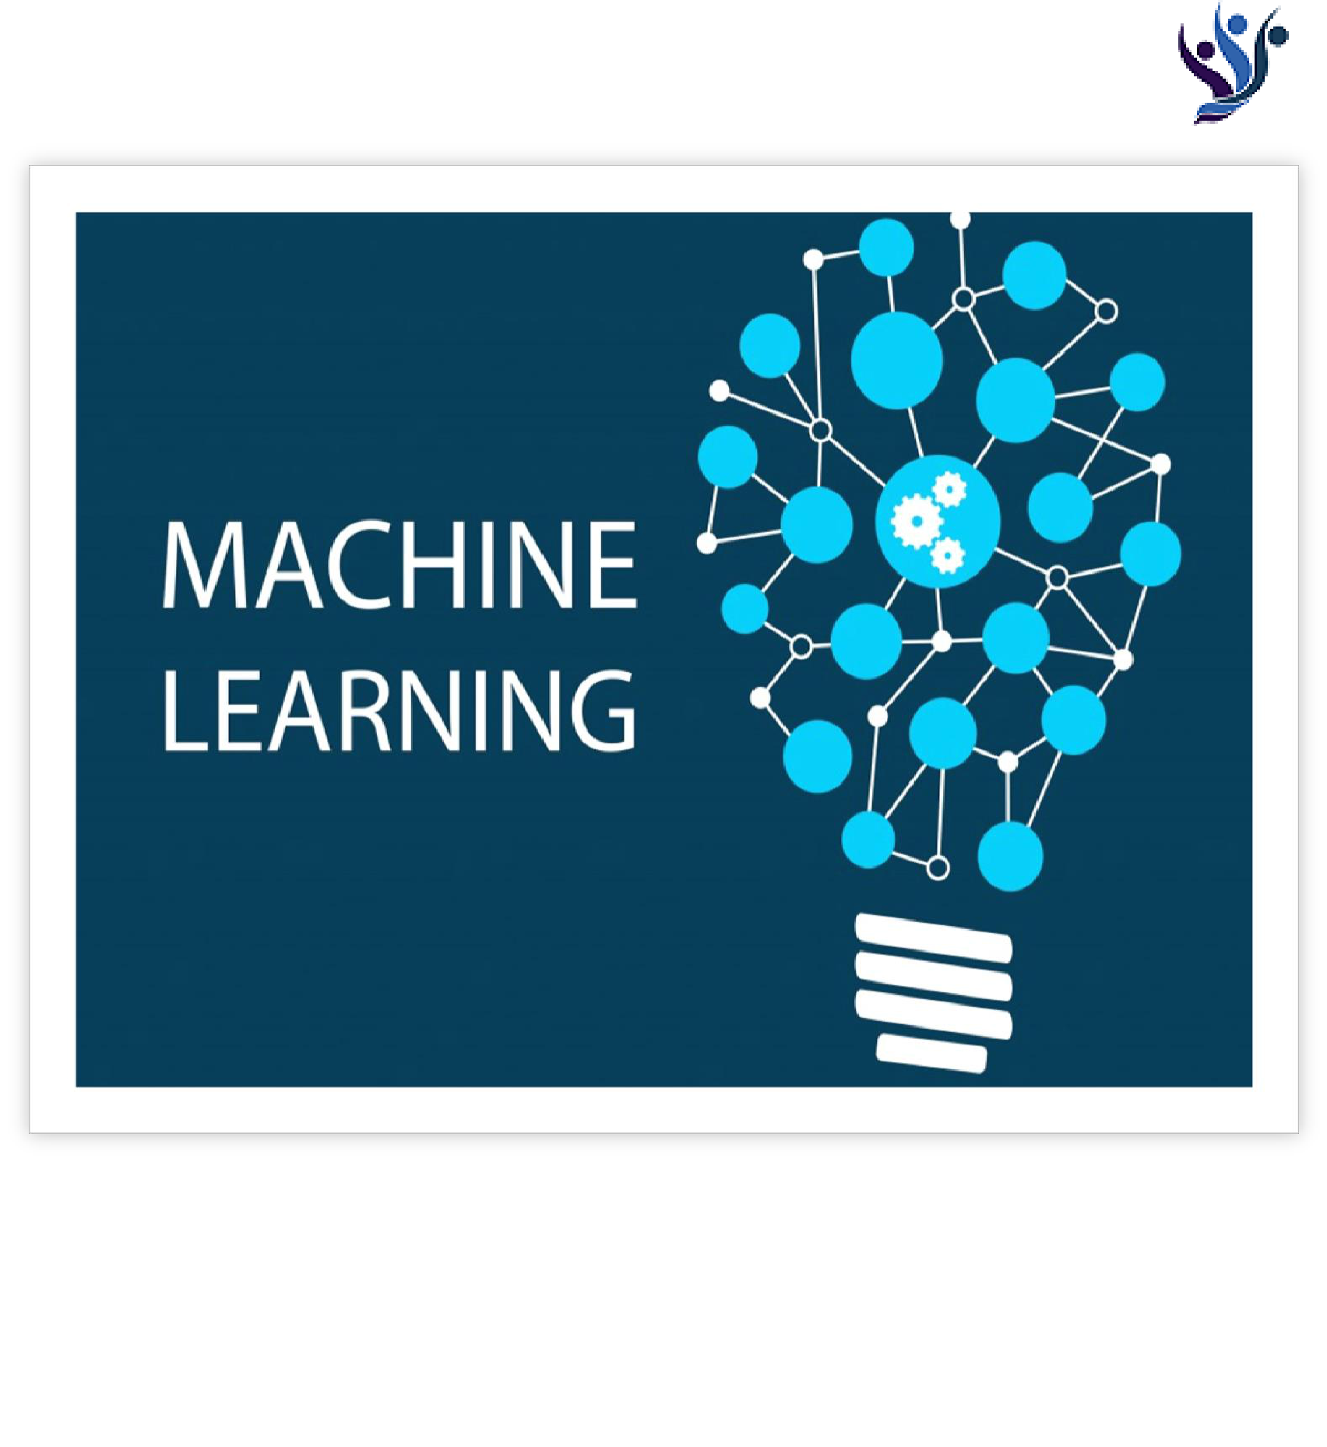

**Olympics Data Mining**



Submitted to: Yogendra Sir

Submitted by: Gaurav Rajpurohit,

Gunjan Khandelwal, Kashish Mathur

TABLE OF CONTENT

* Certificate
* Acknowledgement
* Abstract
* List of figures
* Introduction
* Theory
* Methodology
* Data Pre-processing
* Libraries
* Regression Method Used
* Classification Method used
* Data visualization
* Result Analysis
* Annexure

**Certificate**

Date: 27/06/19

This is to certify that Mr. **Gaurav Rajpurohit**, student of 3rd Year from Department of Computer Science, Global Institute Of Technology, Sitapura, has undergone a Project work from May 1, 2019 to June 30, 2019 in **Data Science & Machine Learning** titled “**Olympics Data Mining**”.

_____________

______________

Project Incharge

Seal

**Certificate**

Date: 27/06/19

This is to certify that Ms. **Gunjan Khandelwal**, student of 3rd Year from Department of Computer Science, Global Institute Of Technology, Sitapura, has undergone a Project work from May 1, 2019 to June 30, 2019 in **Data Science & Machine Learning** titled “**Olympics Data Mining**”.

_____________

______________

Project Incharge

Seal

**Certificate**

Date: 27/06/19

This is to certify that Ms. **Kashish Mathur**, student of 3rd Year from Department of Computer Science, Global Institute Of Technology, Sitapura, has undergone a Project work from May 1, 2019 to June 30, 2019 in **Data Science & Machine Learning** titled “**Olympics Data Mining**”.

_____________ _____________

Project Incharge Seal

Acknowledgement

We would like to express our special thanks of gratitude to our course instructor Mr. Yogendera Singh and Dr. Sylvester Fernandes who gave us the golden opportunity to do this wonderful project on the topic Olympic Data Mining, which also helped us in getting to know about Olympics events. We would also like to show our gratitude towards Rohit sir and Kunal sir, who helped us throughout to develop our project. Last but not least we would like to thank our friends who helped us to improve our project.